TMT/ Raipur/S0789/2026 18-05- 2026

To,
Santosh Gupta
Raipur-Chhattisgarh
Mobile: 9399260894
Dear sirs,

Sub: - QUOTATION FOR HYDRAULIC SHEARING MACHINE

Thank you very much for your enquiry regarding your requirement of Hydraulic Shearing Machine mainly for MS Sheets. We are glad to inform you that we would be in a position to supply you the required equipment. Given below are the required specifications and description of the machine and our terms and conditions.

S No | Description of the unit | Offer
1. | Hydraulic shearing machine with fixed rake angle and shearing capacity 2.4 Meters and 2 mm MS Sheet, along with Power pack 5 HP motor and other electrical fittings. With manual back gauge | Rs 6,50,000/-  (Rupees Six Lakhs Fifty Thousand Only)

SPECIFICATIONS FOR THE HYDRAULIC SHEARING MACHINE WITH CUTTING CAPACITY 2400 M.M. WIDTH AND 2 M.M. THICKNESS.

1. CUTTING CAPACITY IN MS : 2400 X 2 MM.

2. RAKE ANGLE (fixed) : 0.5 DEGREES

3. STROKES PER MINUTE : 8-11

4. NUMBER OF HOLD DOWNS : 9 NOS

5. BACK GAUGE (MANUAL) : 750 M.M.

6. MOTOR HP : 5 HP (Crompton)
- OVERALL DIMMENSIONS :

a) LENGTH : 3000 M.M.

b) BREADTH : 1600 M.M.

c) HEIGHT : 1600 M.M.

8. BED SIZE. : 2400 X 550 M.M.

9. COST OF MECHINE. : RS.6,50,000/- + TAXES.

10. MODE OF PAYMENT. : AS PER THE QUOTATION.

11. DELIVERY. : AS PER THE QUOTATION

GENERAL TERMS & CONDITIONS:

- Price quoted per unit ex-work. Hyderabad.
- Following charges are additional to your account.
- Freight Charge : As actual to be borne by you.
- Sales Tax : 18% Extra as applicable
- Packing charge : As actual to be borne by you.
- Insurance : As actual to be borne by you.
- Payment : 50% advance along with order balance before delivery but after inspection at our works.
- Delivery : with in 1 months
- Validity : One month from the date of submission.
- Inspection : Inspection at our works prior to dispatch.
- Warranty : The machine is warranted for a period of 12 months from the date of dispatch against any manufacturing defects/ faulty material or bad workmanship of any part or component but not against any kind of abnormal or improper use of machine. Defective part or component will be replaced or repaired free of cost. Electrical components are outside the scope of this warranty.
- Commissioning : Erection & commissioning done by you, but required technical support & guidance provide by us at additional cost.

NOTE:
- Oil is not in scope of our supply.
- Raw material for trial is to be arranged by you at your cost.

We are sure you will find our offer in line with your requirements. Should you require any further clarification please contact 9246221106
Thanking you and assuring you of our best services

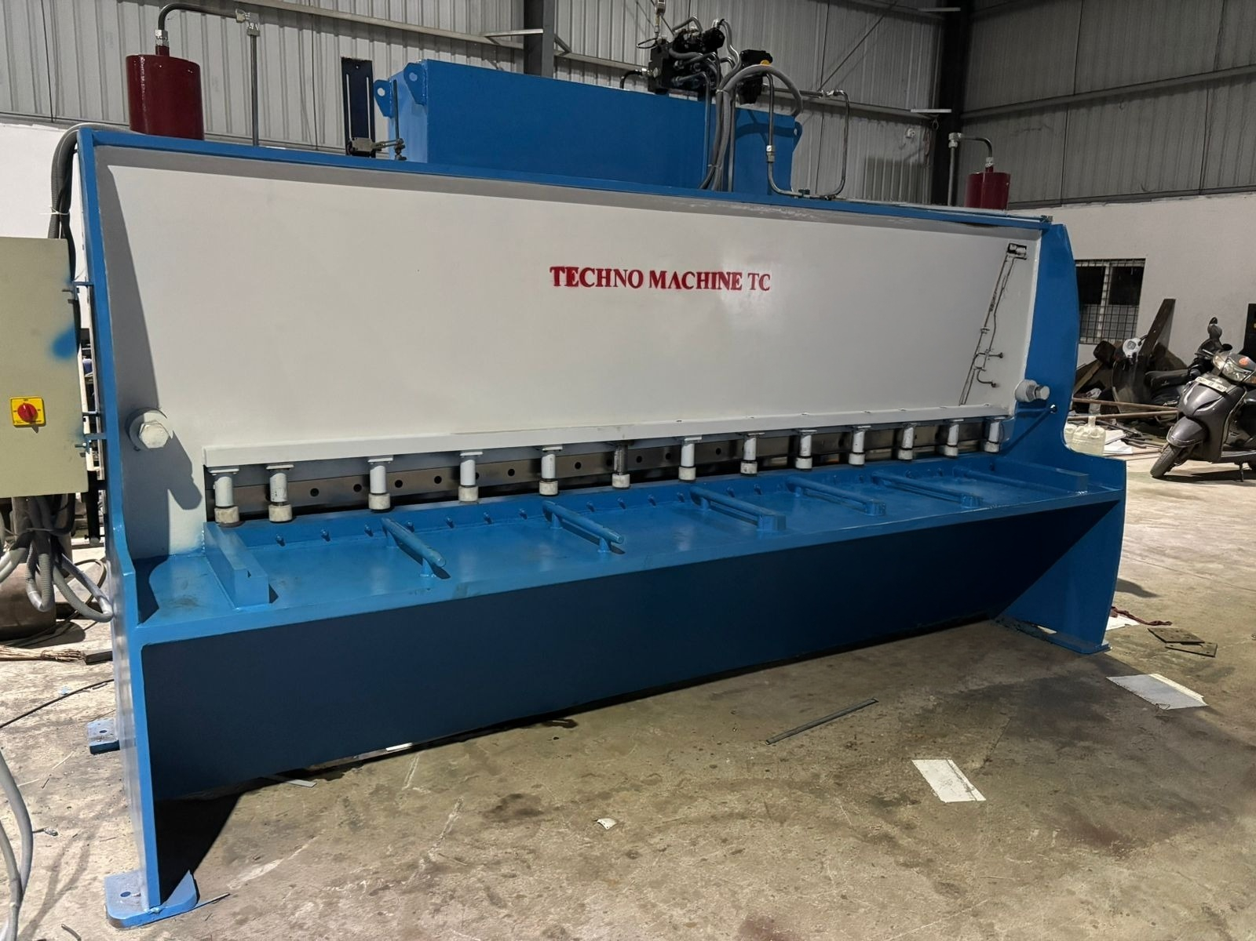

For TECHNO MACHINE TOOLS

( T. SIVARAMAKRISHNA)

